Term Project: Drag and Drop Web Application

Team Members:

Moayed Aljaser

Adam Coard

Amr Hassanein

**Main Overview:**

Drag and drop is an online programming studio to allow users to create new web pages and modify their existing web pages. The program is based on GUI. It allows people with no prior programming experience to develop their own unique web page. For example, a user may decide to sign up for the service and they will have simple options to create their own web page, rather than having to program the web page from scratch. To use the web page generator, add which features you would like using the buttons. Then, you can customize the appearance of the web page, for example font color, size and much more. Once you have added all of your desired features and changed your design, you can drag the features in the design box and create your own preferred design. You can save your progress by setting cookies and returning to the site at a later date to see your progress is still there. The option of clearing cookies is available to use so that you can start over. Also, without drag and drop the users will only have the choice of having the buttons at a fixed position, so this programming studio can help eliminate that issue.

**Contributions:**

**Moayed Aljaser**

* Came up with idea of using cookies
* Implementation of CSS
* Implementation of features allowing change of CSS
* Implementation of add button, and reset page features
* Worked on final report, progress report, and presentation

**Adam Coard**

* Came up with idea of using drag and drop to move features added
* Implementation of CSS
* Implementation of functions to allow drag and drop
* Implementation of add heading, add text, add link, add date/time, add line break, and add horizontal rule features
* Worked on final report, online technical document, presentation, and progress report

**Amr Hassanein**

* Implementation of setting cookies
* Implementation of clearing cookies
* Implementation of CSS
* Implementation of add image, add video, add short quote, add blockquote, and add text box features
* Worked on final report, progress report, and presentation

Each member of the group completed the same amount of work. The features that could be added to the site were divided evenly and each group member implemented their portion. The JavaScript and CSS files were also worked on simultaneously to perfect the program.

**Implementation**:

The purpose of this program is to create a website that allows users to create their own website which implements a feature to allow the user to drag and drop html elements into the website. The project is comprised of three files; an HTML file, CSS file, and a JavaScript file. The HTML file is the main skeleton of the program. It holds all the buttons that allow the user to add elements to their webpage. Furthermore, get element by id was implemented which helped to connect between the buttons and the functions. The CSS file holds code that styles the main website. The CSS file changes elements like the website alignment, colors, fonts, etc. The third and final file is the JavaScript file which holds the code that allows the user to drag and drop elements that were added to their website which allow user to layout the page as desired, as well as the set and clear cookies features. This is the main part of the program because it will allow the user to move the elements position anywhere on the page. There is also JavaScript code that implements the HTML and CSS elements that can be added to the user’s page which allow the user to manipulate with background color, font size, font color, and the text of page alignment or add elements.

**Lessons Learned & Future Work:**

This project was very interesting. It allowed students to use their own creativity to produce a website that allows users to create their own website and change the position of elements on the page. It allowed us to further our knowledge in the languages that we have previously learned. Our program helped us learn more about the uses of JavaScript through the implementation of the drag and drop feature. We also learned a lot more about CSS just because we wanted to make the website look clean and lined up. Future projects based off of this program would be to apply further upgrades and feature to the site. For example, you could allow the user to resize elements that are added to the website. You could also allow for the user to create a navigation bar or menu.

**Screenshots:**

*User Interface*

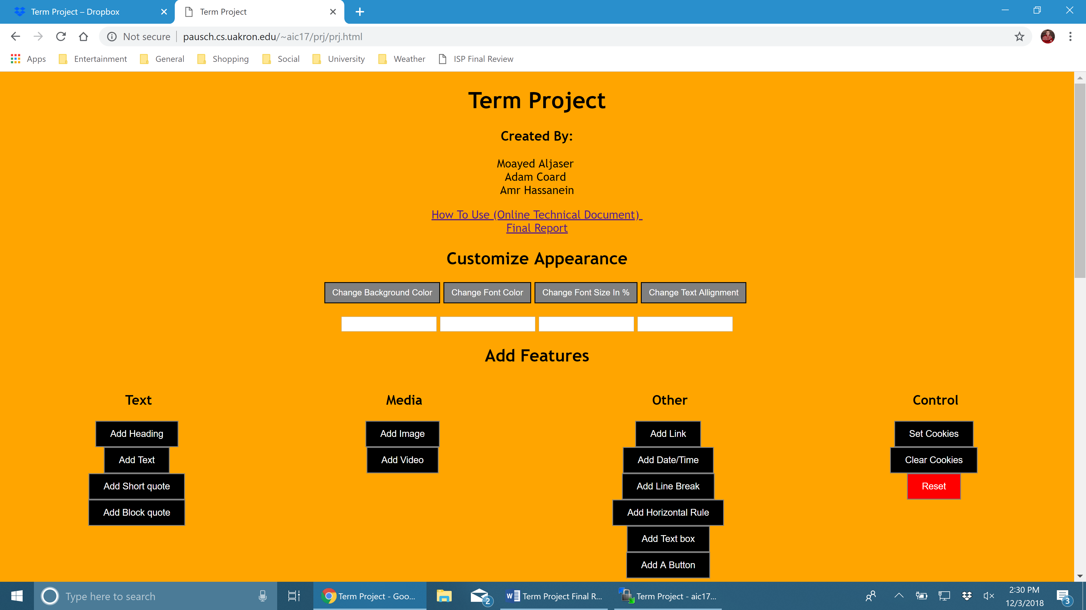

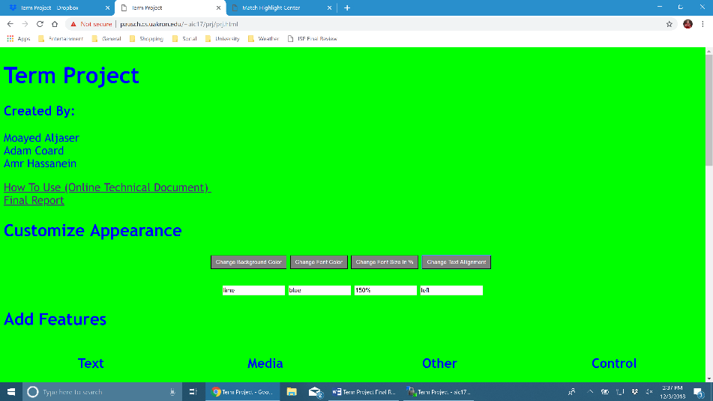*Design Demonstration*

